Practical no. 1
Name :- Danish Altaf Solkar Enrolment no. :-24111590805
Class :- CO3K – B Subject :- DMS
Aim:- Install the provided database software

Install SQLplus on Windows

Follow the below steps to install SQLPlus on windows:
Step 1: First browse to this link.
Step 2: Then we have to click on the download button on the right side.

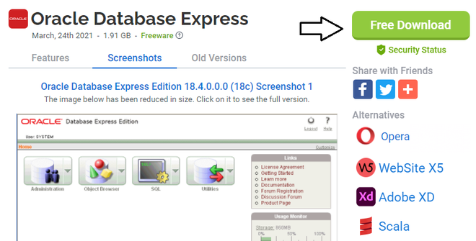
Step 3: Then on the next page you will find the Start Download button. There you have to click.
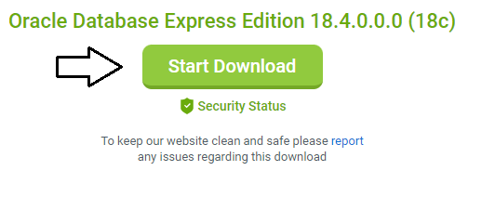
Step 4: Then in the downloaded zip file there will be a setup.exe file. We have to click & run it.

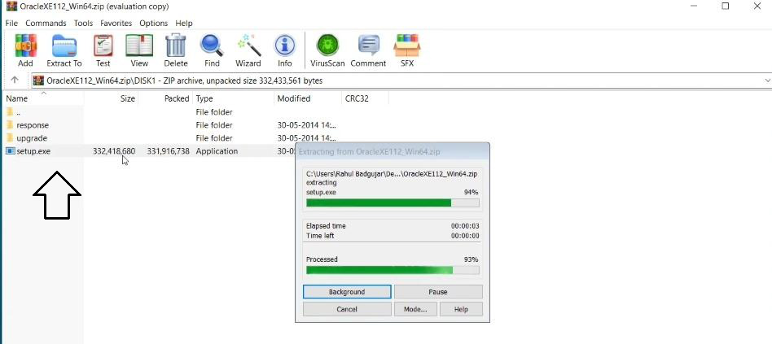
Step 5: Then the installation will start.

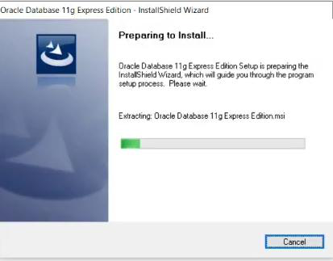
Step 6: Then you have to accept terms & click on Next

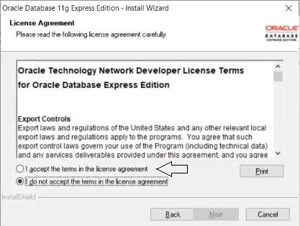
Step 7: Then you have to enter a password & confirm it. You have to remember the password for future references.
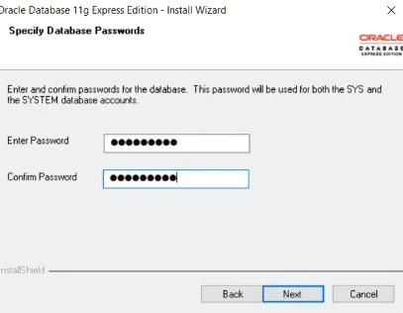
Step 8: Then click Install.
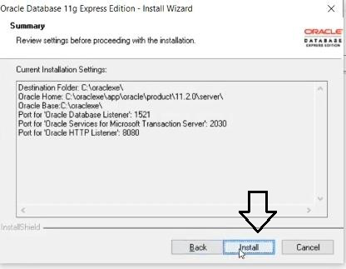
Step 9: Installation will start & it may take some time.
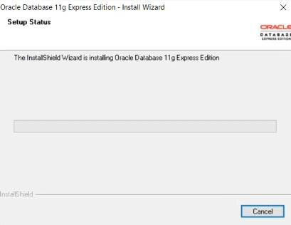
Step 10: After installation, you will find oraclexe folder in the C drive.
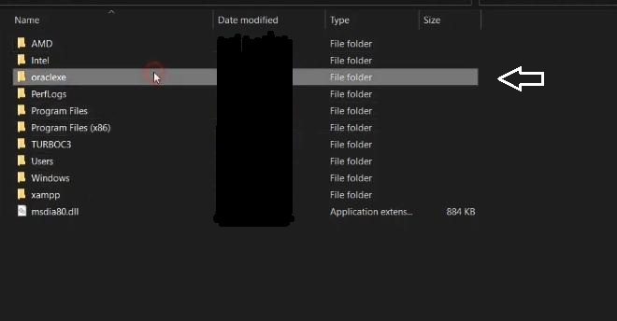
Step 11: You have to enter that folder. Then bin folder there you will find sqlplus exe file. So, your installation is successfully completed.
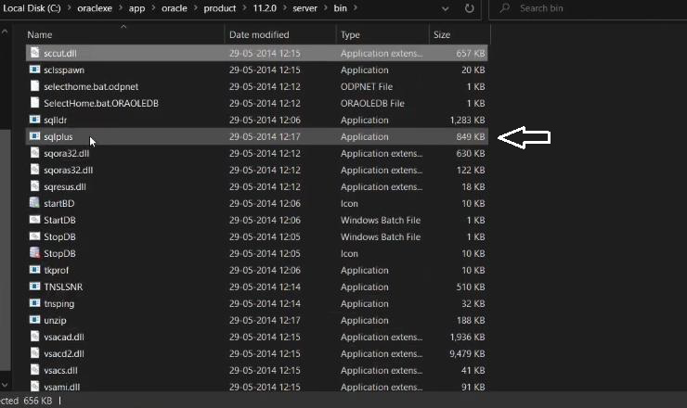

Conclusion: Hence we have successfully installed Oracle database to interact with Database.

